Use the online AWS and Azure calculators to determine the monthly cost of storing data 2 sizes of data :

(1)  100 TB

(2)  1  Petabyte

Use the following storage options for both data sizes.

1. AWS S3 standard
2. AWS EBS
3. AWS Glacier
4. Azure Blob storage

**AWS S3 Standard:**

100 TB:

Based on the images below. The overall price for 100 TB of storage in the USA East (N. Virginia) region is about 2,534.27 dollars.

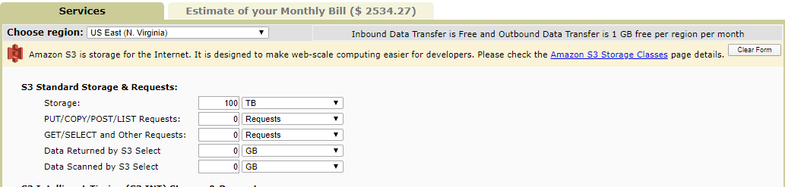

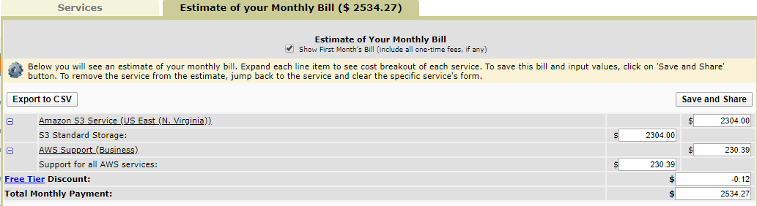

1 Petabyte:

Based on the images below. The overall price for 1 PB of storage in the USA East (N. Virginia) region is about 24,464.01 dollars.

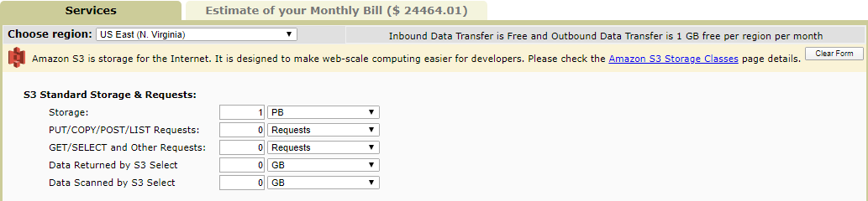

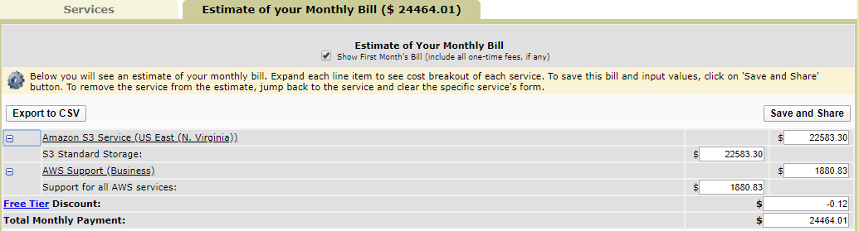

**AWS EBS:**

100 TB:

I broke down the 100 TB into 10 10k GB instances. Based on the images below. The overall price for 100 TB of storage in the USA East (N. Virginia) region is about 10,996.70 dollars.

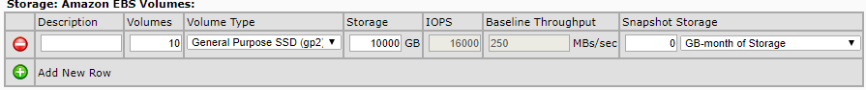

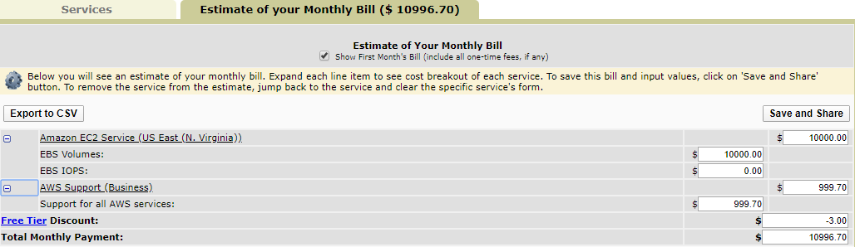

1Petabyte:

I broke down the 100 TB into 66 15k GB instances. Based on the images below. The overall price for 100 TB of storage in the USA East (N. Virginia) region is about 105,846.85 dollars. Which honestly, it is not worth it!

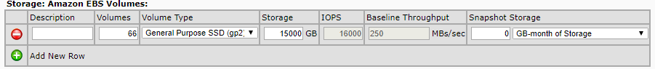

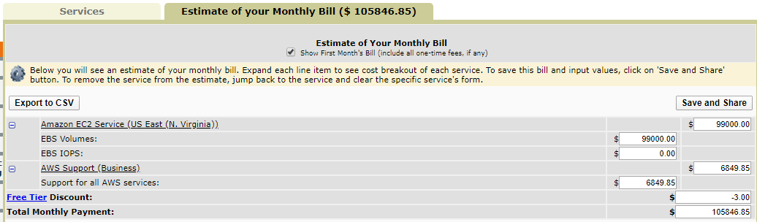

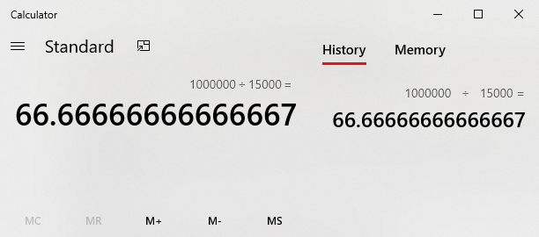

**AWS Glacier:**

100 TB:

Based on the images below. The overall price for 100 TB of storage in the USA East (N. Virginia) region is about 409.60 dollars.

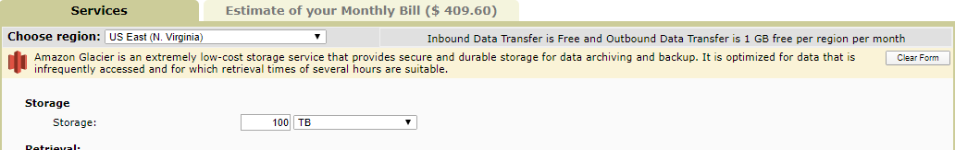

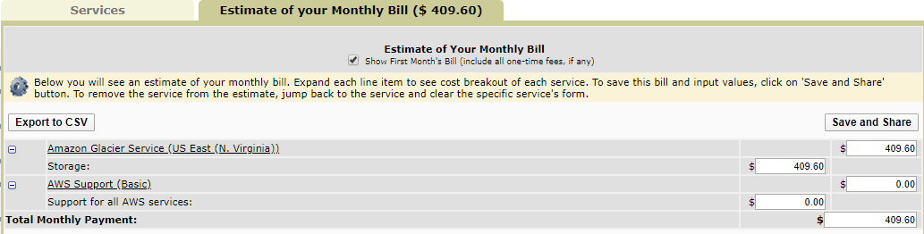

1 Petabyte:

Based on the images below. The overall price for 1 PB of storage in the USA East (N. Virginia) region is about 4,613.75 dollars.

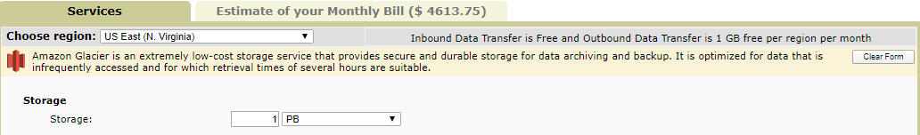

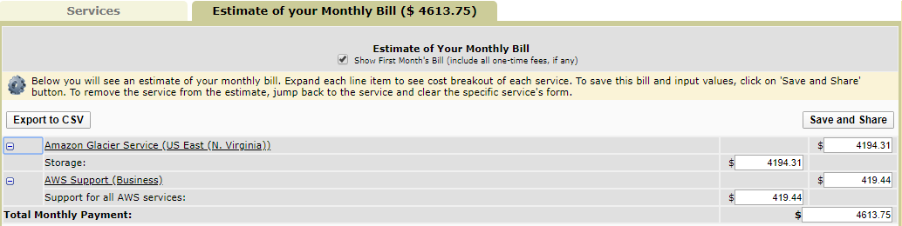

Azure Blob Storage:

It’s a bit funky in a sense that they provide prices for their storage services in a 1 year ,3 years services and “Pay as you go” service. The 1 year and 3 years services as self-explanatory in the image below. Pay as you go service is a bit different So here is a quick break down.

100 TB - 100,000 GB:

Premium - 15,000 dollars. Hot - 1,700‬ dollars. Cool - 1,000 Dollars. Archive -

1PB - 1,000,000 GB:

Premium - 150,000‬ dollars. Hot - 17,000 dollars. Cool - 10,000. Archive - 990‬ dollars.

